|  |  |
| --- | --- |
| How to | D:\projecten\1210326 MDBA ROWS (local, See N)\C. Report - advise\Workshops\2015-02 workshop 3 UAT, end user training\Screenshots\DELTARES_ENABLING_RGB.pngSource - Prepare SA daily trade data for Source RO |
| Description | D:\Software_delft-fews (local, See P)\Marketing\Icons (FEWS_logo_icon)\Delf-FEWS-256x256.pngEnter observed (actual) data and add or create short term forecast |
| Comments | Please be aware that the screenshots may deviate slightly from the application |
| version | 2016-01 |

Daily trade adjustment at South Australia border is made up of SA deferred, Undelivered trade combined for NSW and VIC and Environmental trade from both TLM and CEWH. All 5 time series are included in the export to Source RO. Note: Export starts at a fixed date (like Jan 1), which is changeable in Topology.xml.

To create the Daily trade adjustment:

1. Select the node River Operations > Prepare data for Source RO > Prepare Qtrade for Source RO in the Workflows display.
2. Open the *Plot Overview* and enter the data for each element of the daily trade
3. Complete each source in the *Plot* display, switch to editmode with the *pencil* buttonNote: zoom out to reveal the time series, which have a monthly time step
   1. SA deferred: enter actual data for previous months + up to 6 months of “forecast”. Previous “forecasts” are stored separately.
   2. Save edits by clicking the floppy disk or moving to the next plot
   3. Undelivered trade: Enter the End of month undelivered trade at the first of the following month (e.g. 31 Jan is entered at 1 Feb). This trade volume is transformed into a forecast according to a fixed ratio for each month of the remaining months of the water year.
   4. Save edits by clicking the floppy disk or moving to the next plot. Run the workflow to see the generated results.



* 1. Environmental trade: enter actual data for previous months for both TLM and CEHW + up to 6 months of “forecast”. Previous “forecasts” are stored separately.
  2. Save edits by clicking the floppy disk

1. 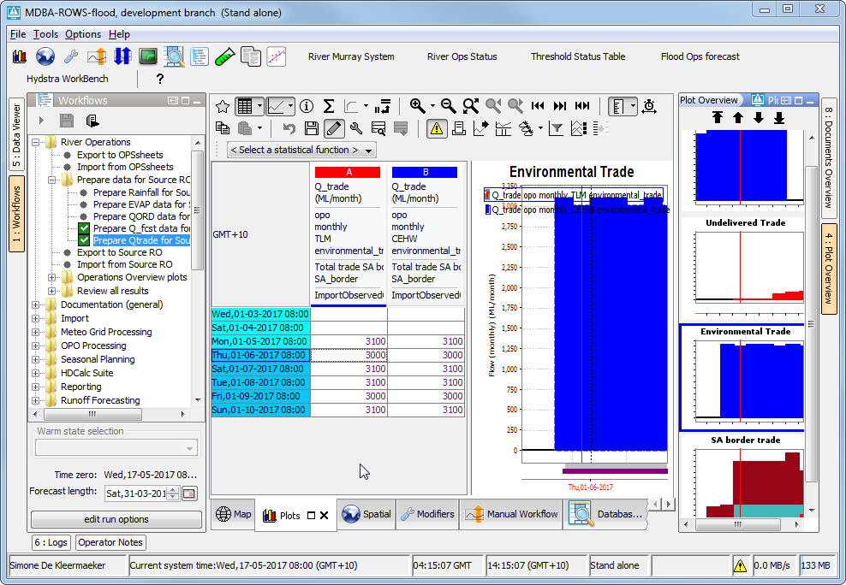Run the workflow, but make sure you saved all edits first (floppy disk). The total SA daily trade is shown in the plot “ SA border trade”

1

3

2

